**PCBA 8.7 Randomly generated 50 question practice exam:**

[**https://www.classmarker.com/online-test/start/?quiz=n7x6229096759c47**](https://www.classmarker.com/online-test/start/?quiz=n7x6229096759c47)

**Self Study Mission Test:**

[**https://academy.pega.com/mission/business-architect/v4/test/in/35761**](https://academy.pega.com/mission/business-architect/v4/test/in/35761)

**Case Management 38%**

<https://www.classmarker.com/online-test/start/?quiz=gev6228cc8eba137>

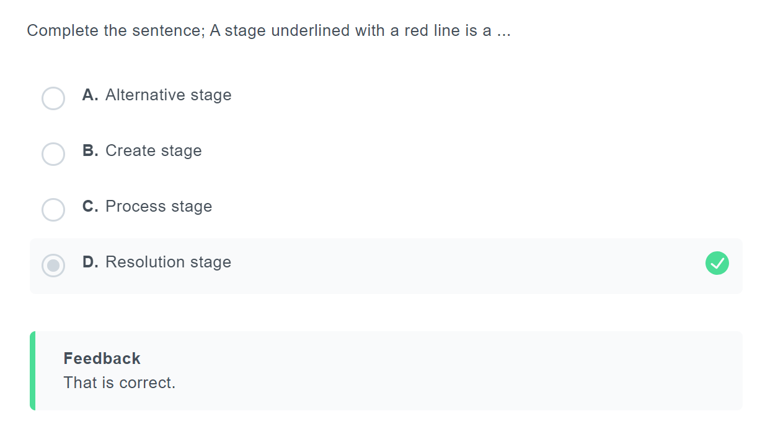

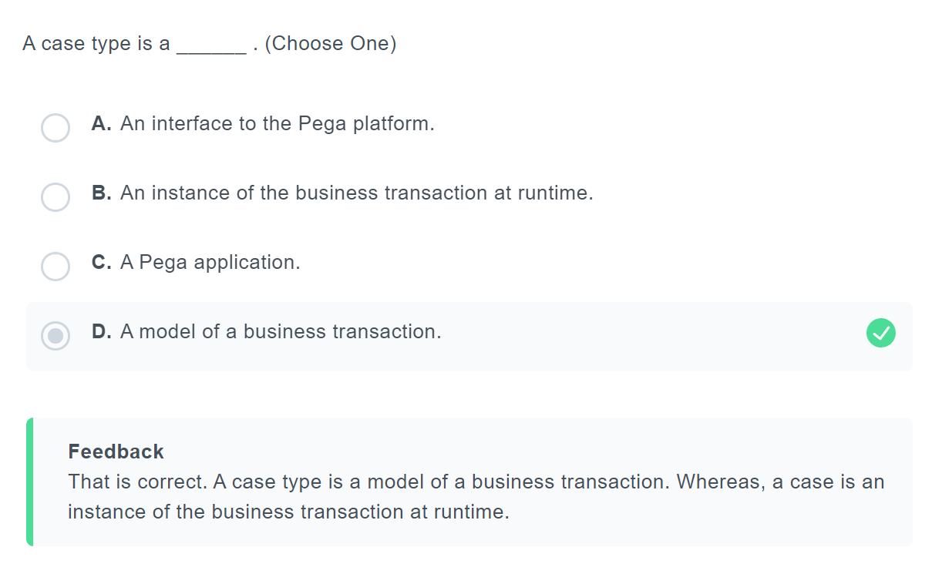

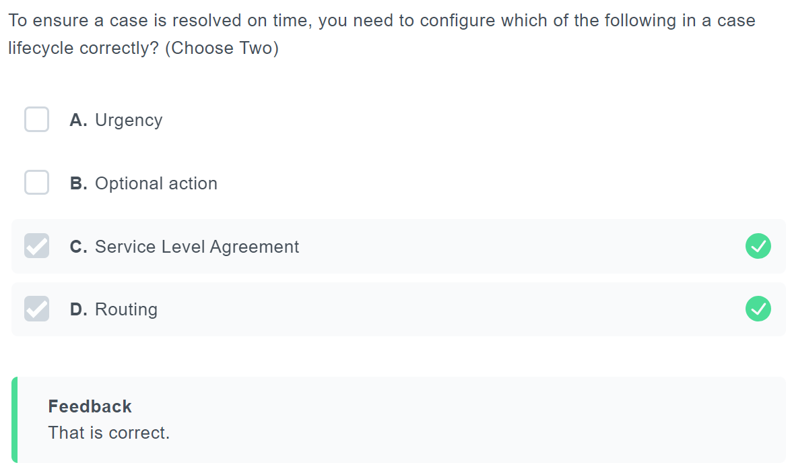

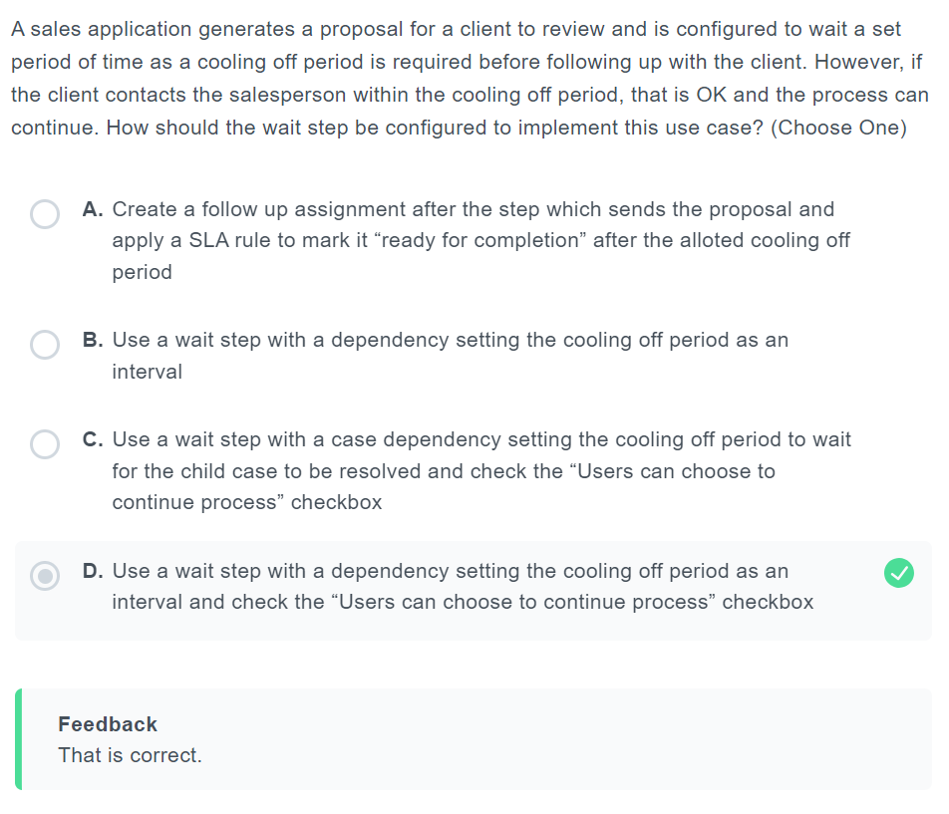

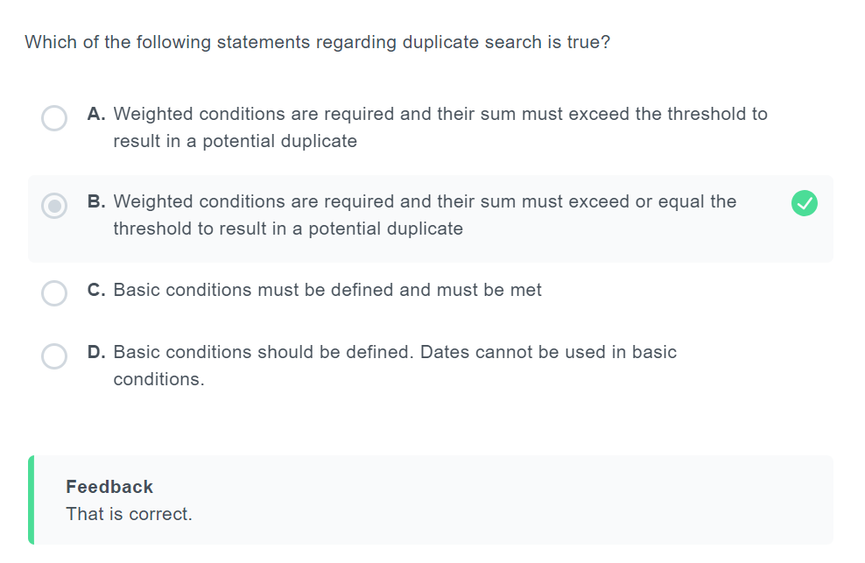

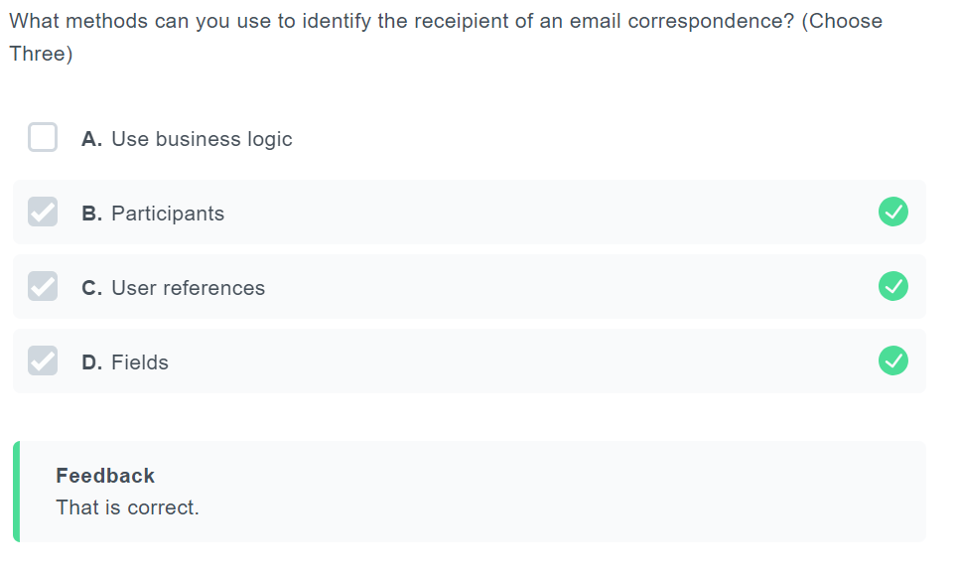

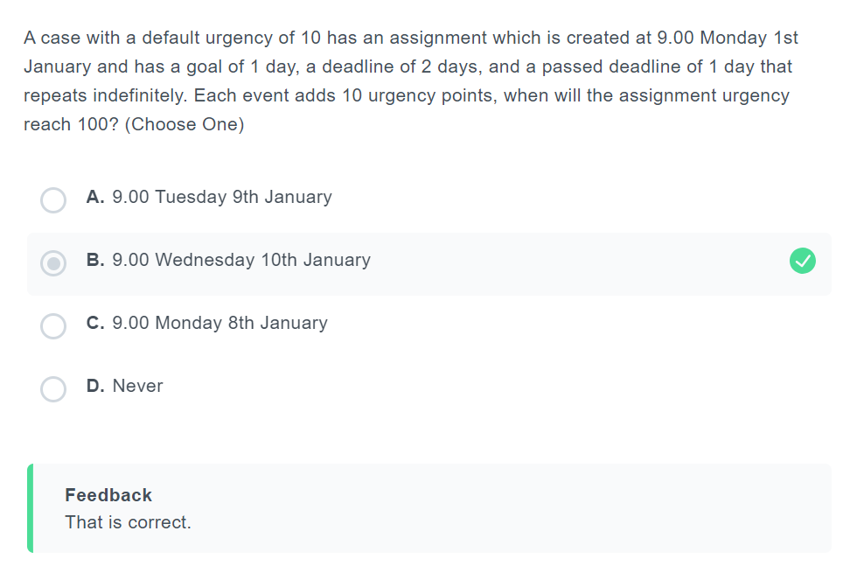

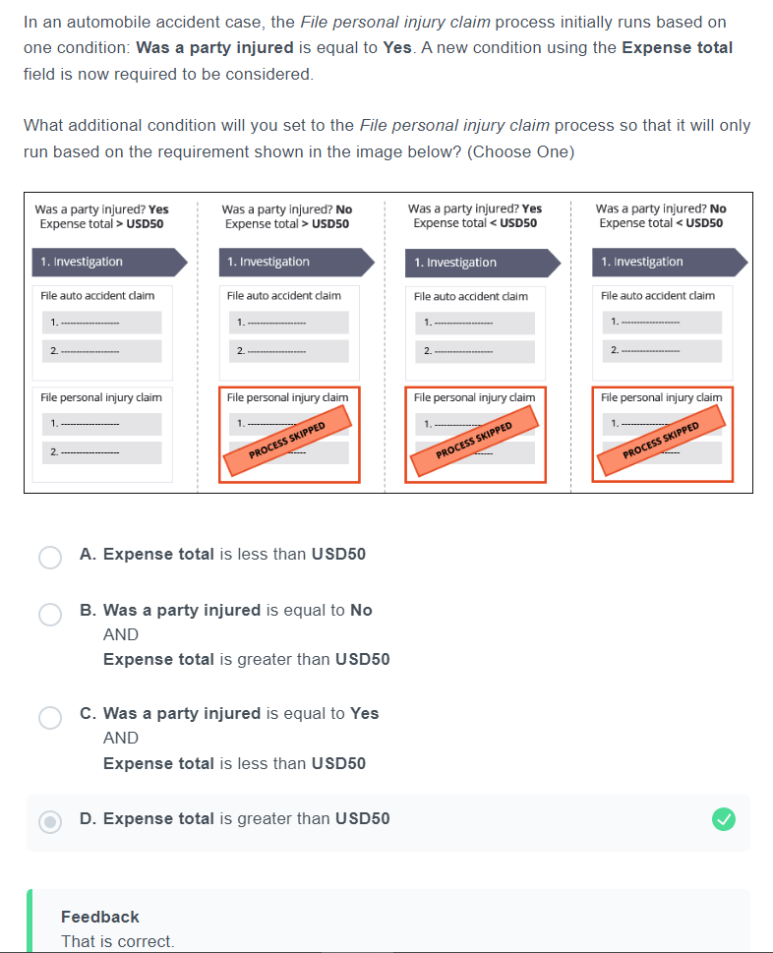

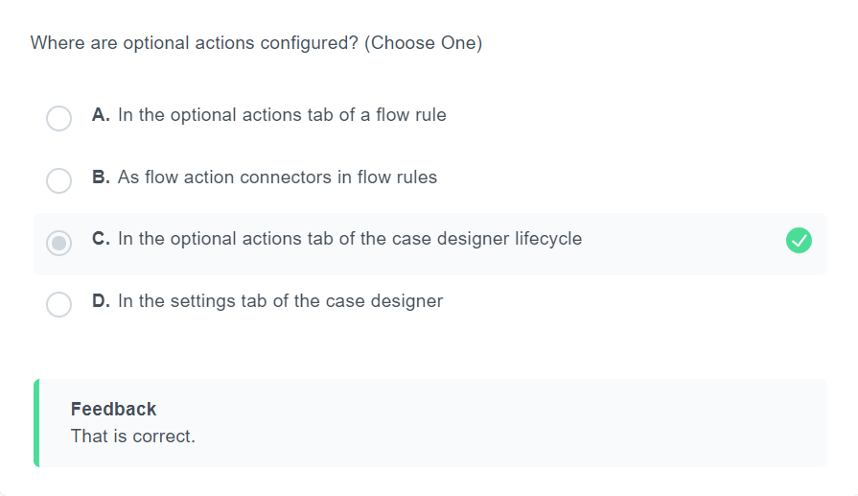

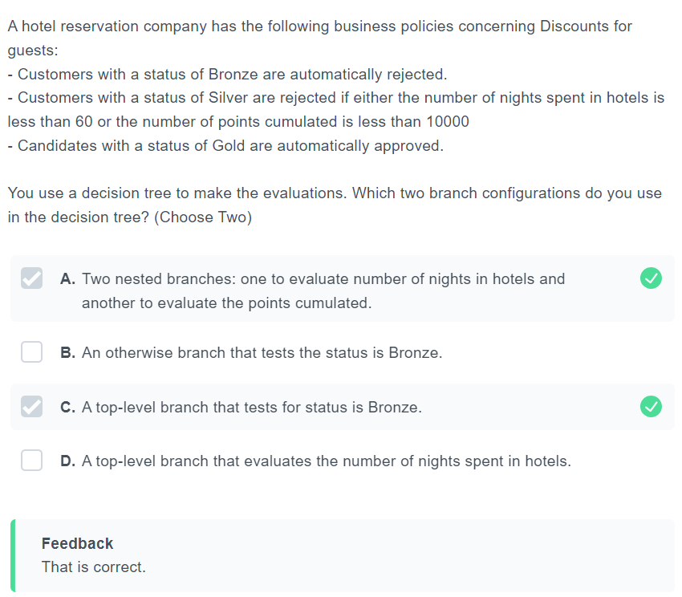

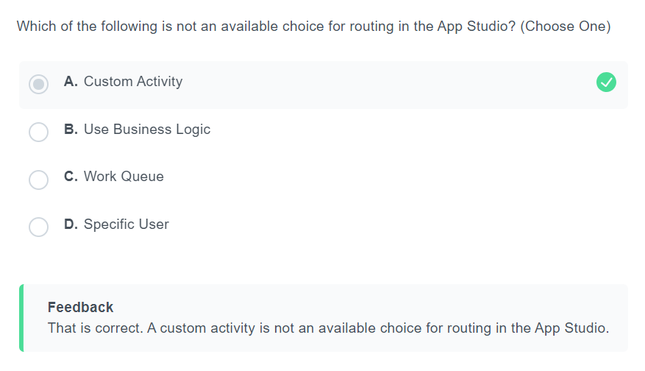

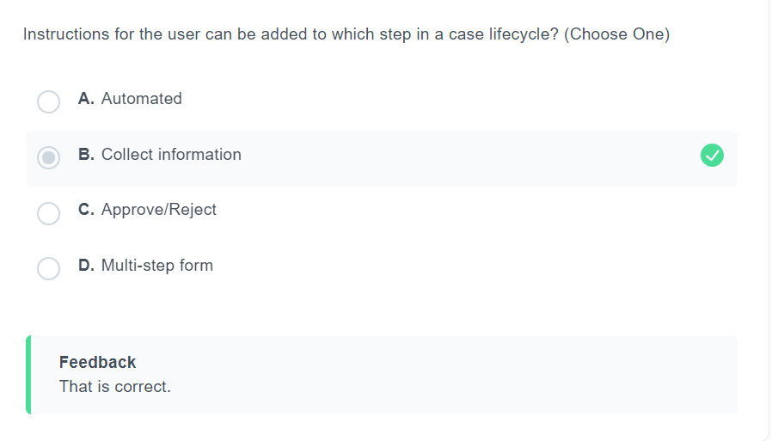

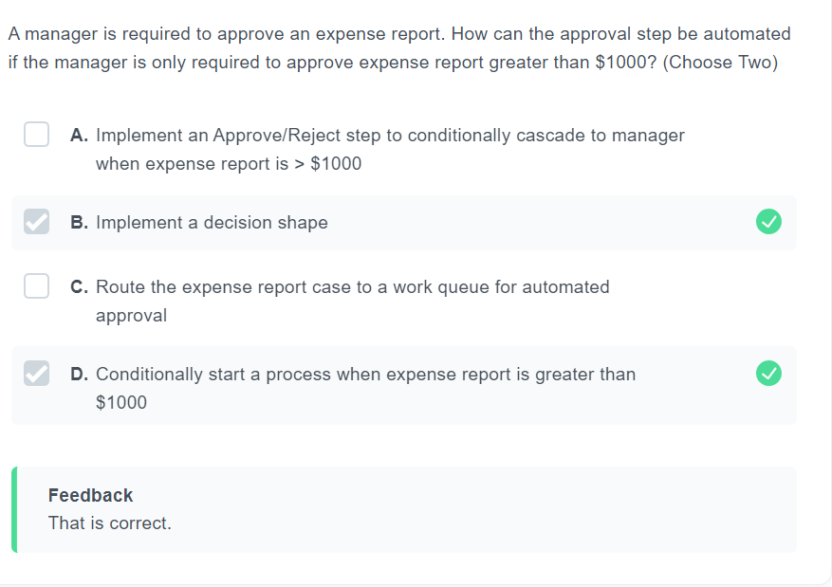

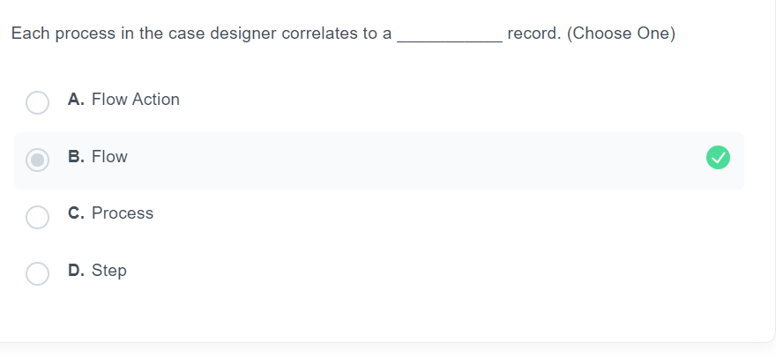

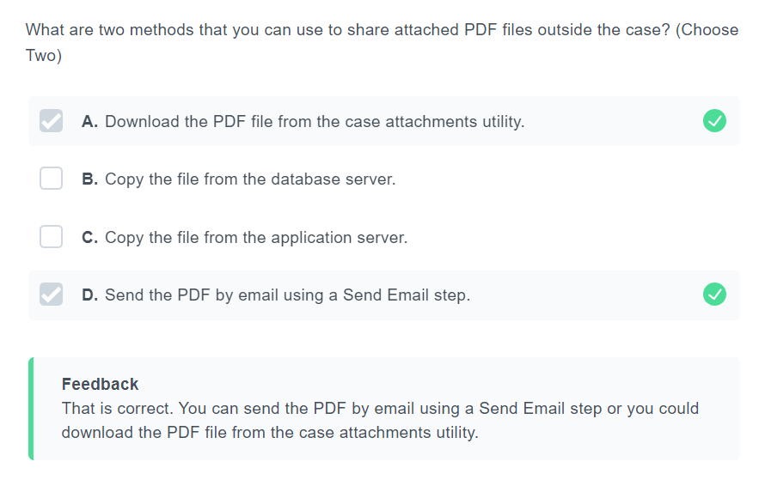

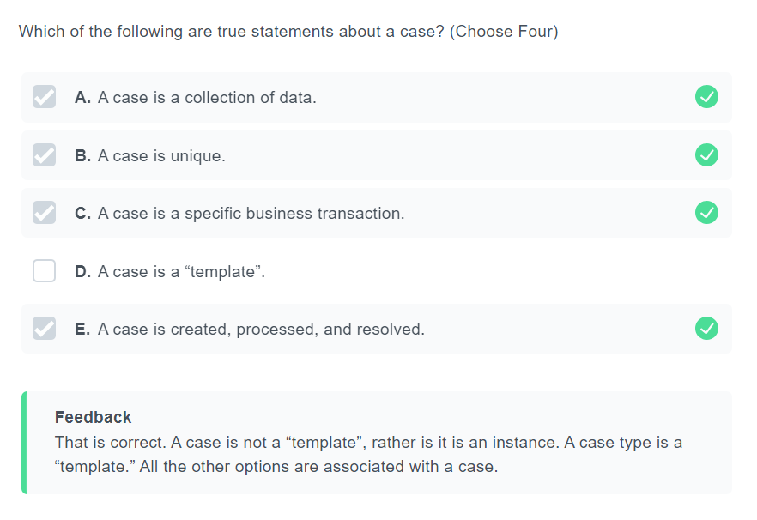

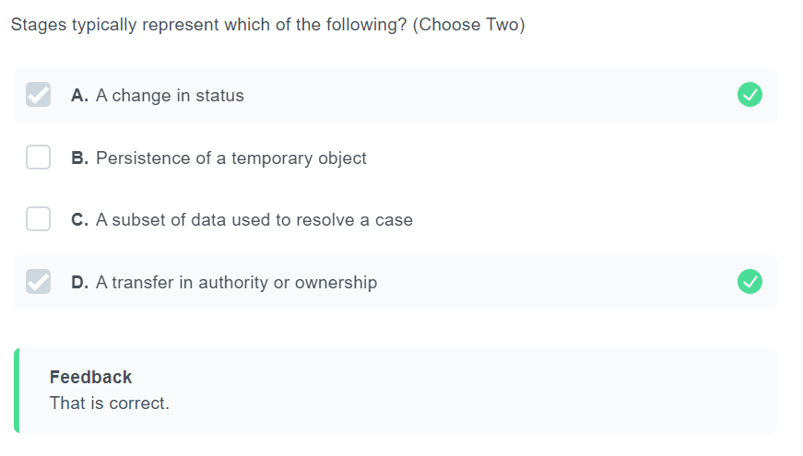

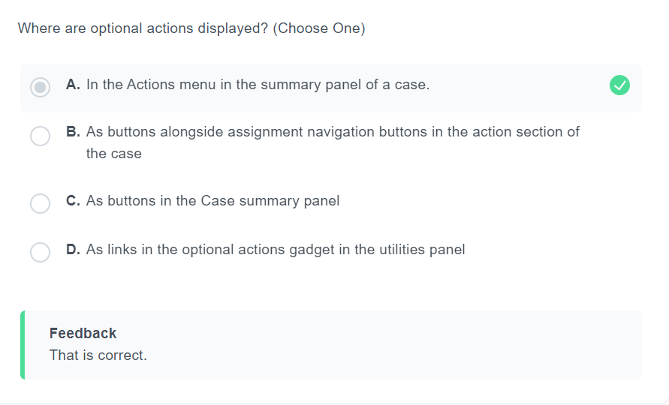

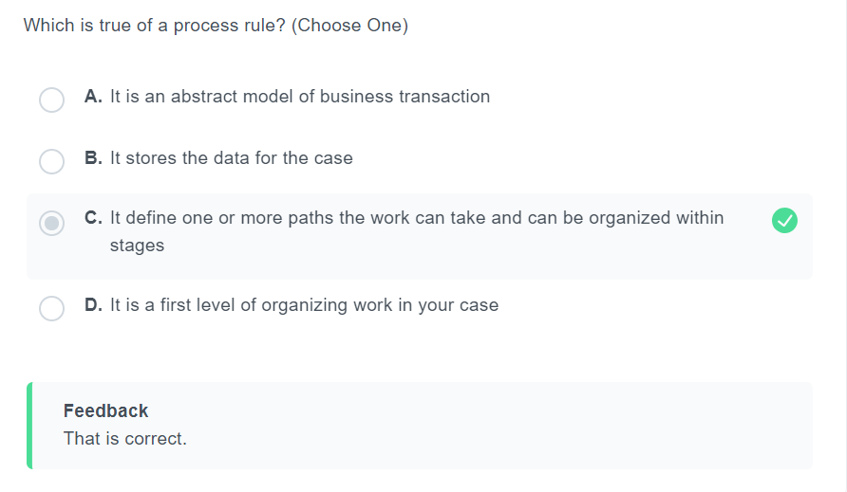

**Data & Integration 15%**

<https://www.classmarker.com/online-test/start/?quiz=3a96228fdd7b4e89>

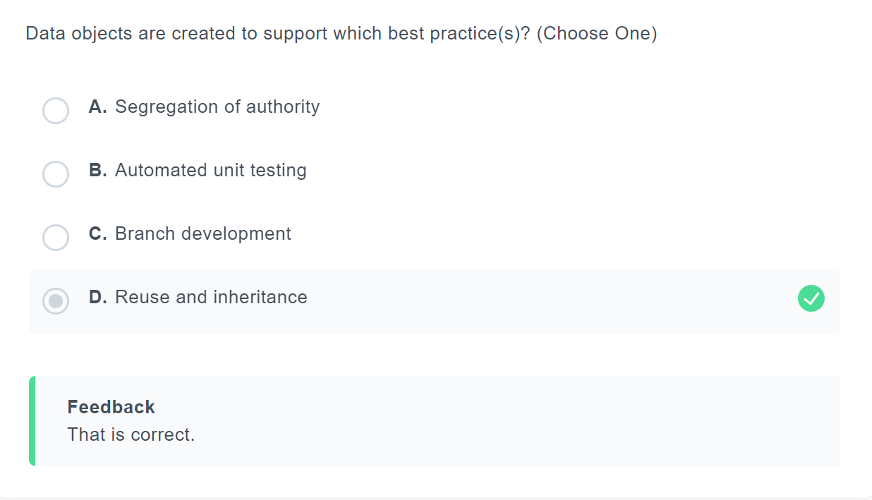

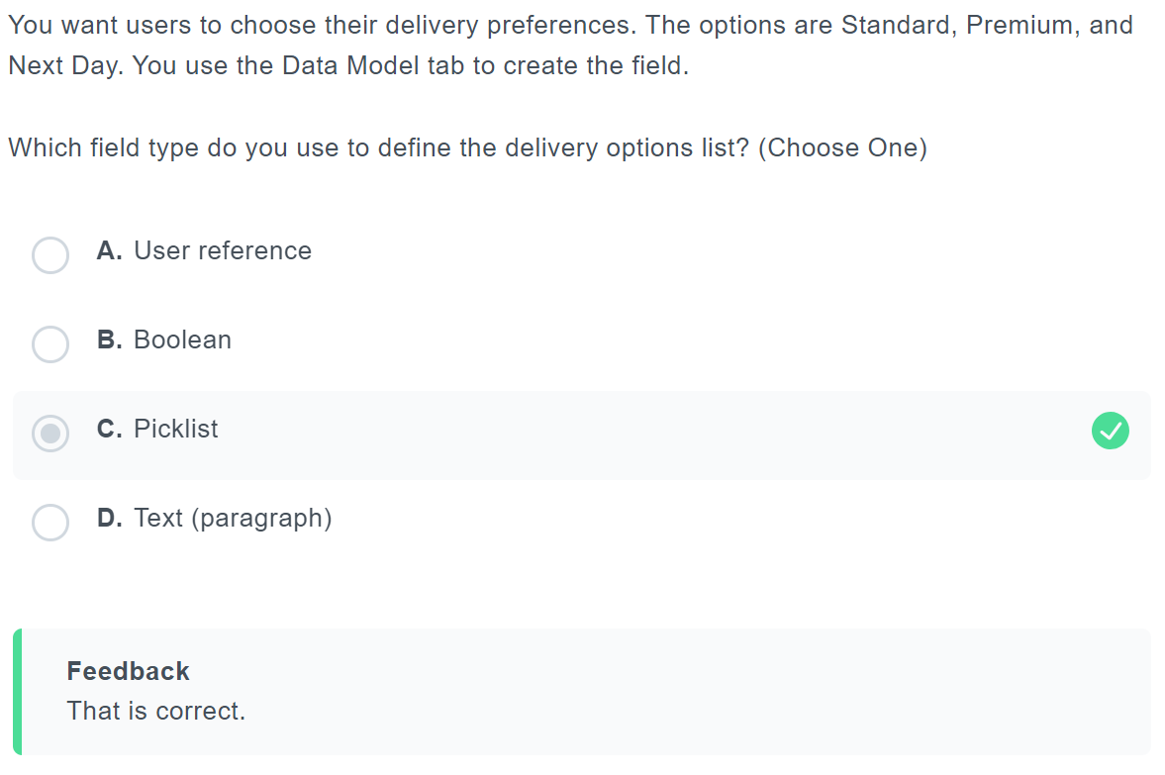

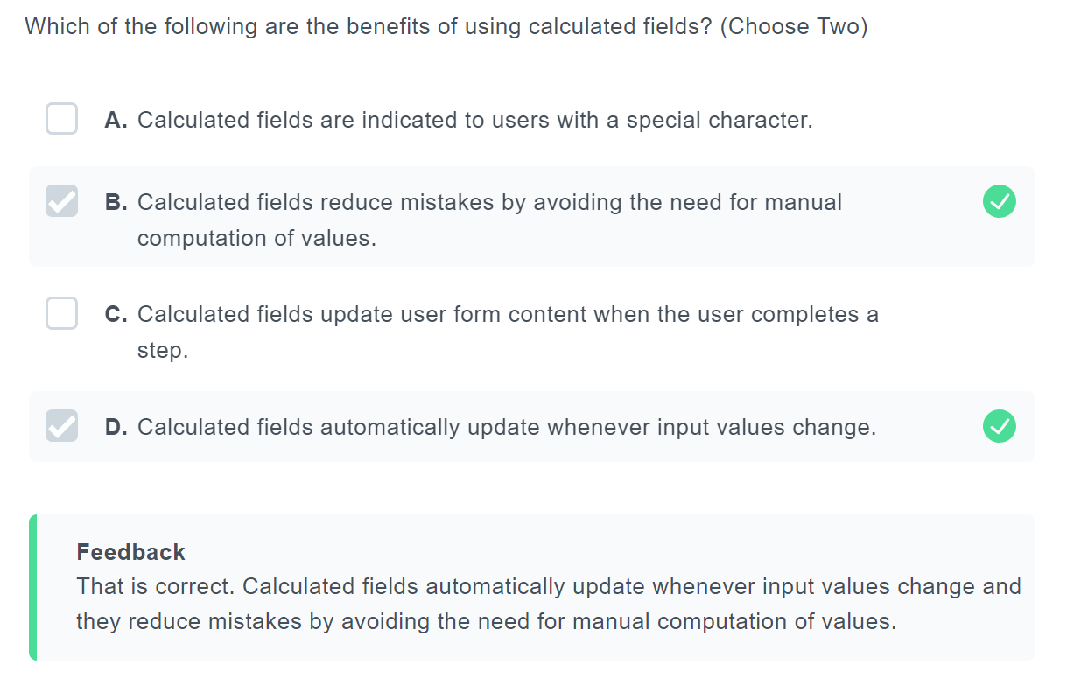

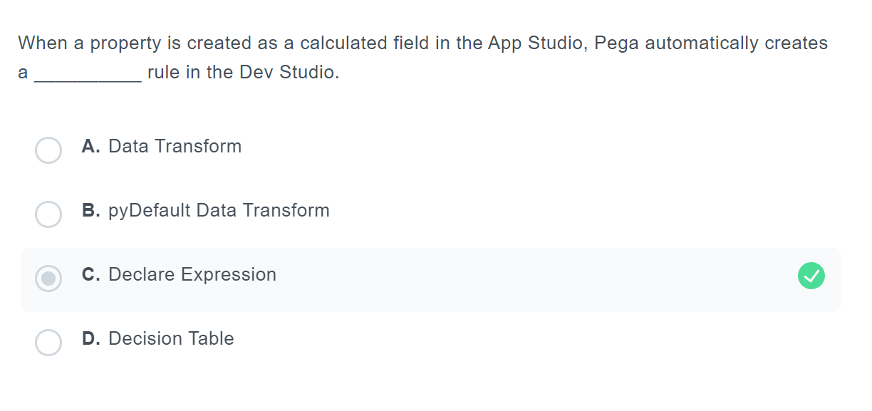

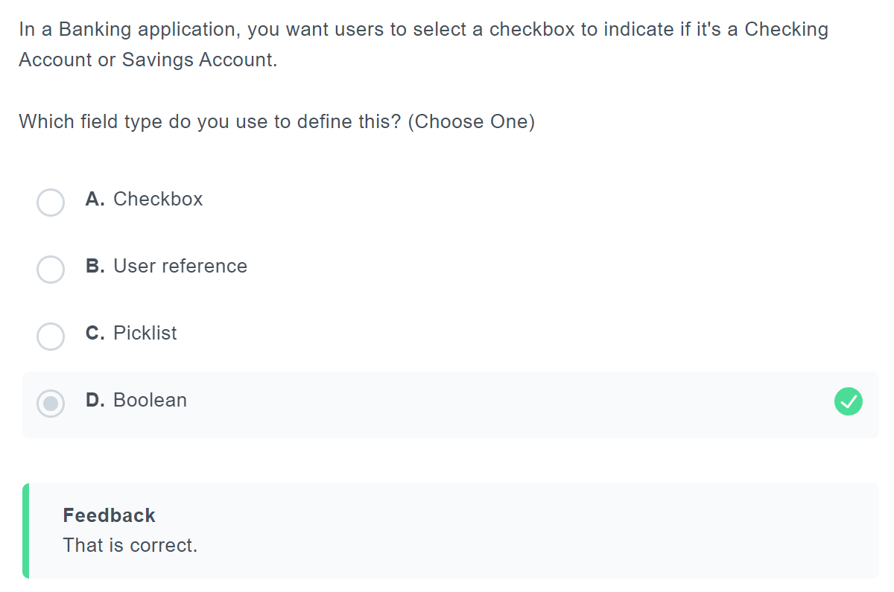

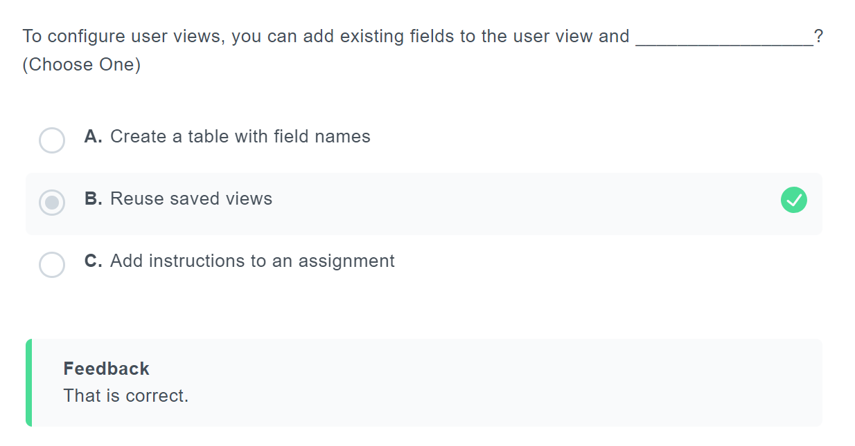

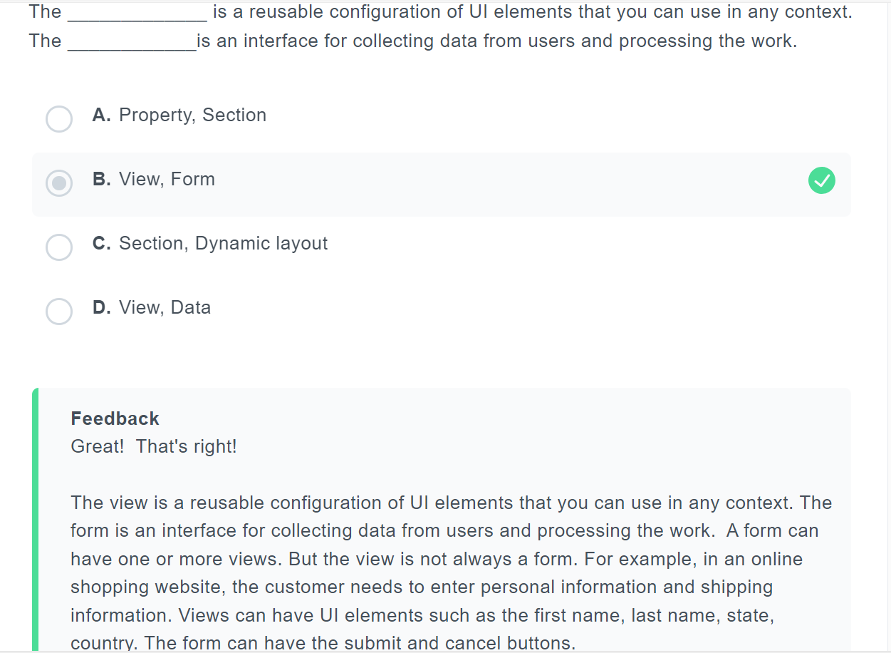

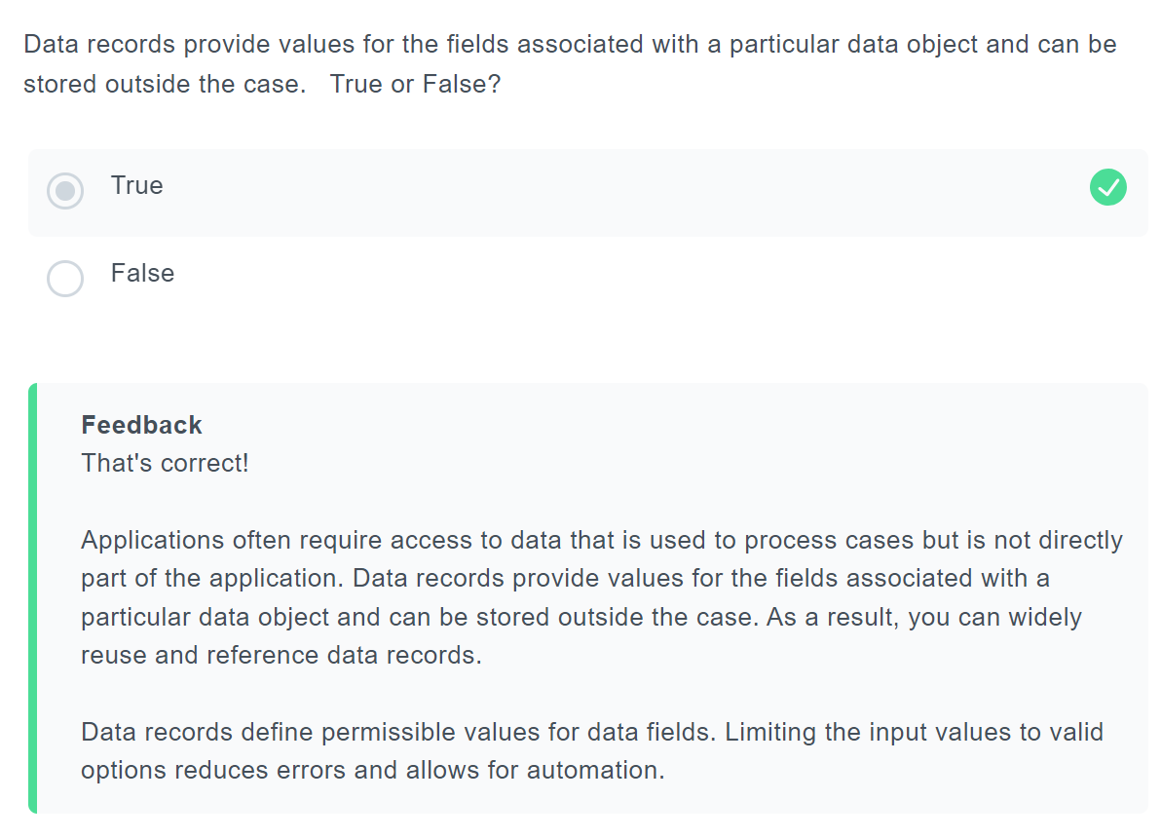

**Pega Express Methodology 12%**

<https://www.classmarker.com/online-test/start/?quiz=n7n62290be9efdab>

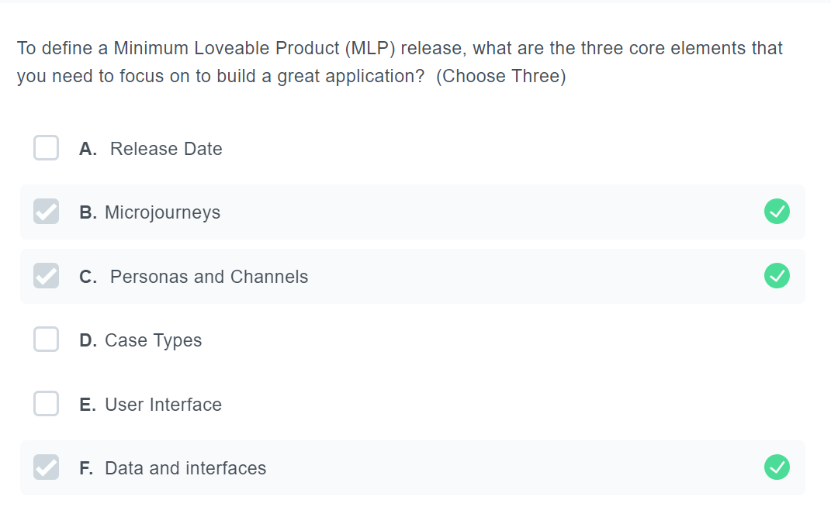

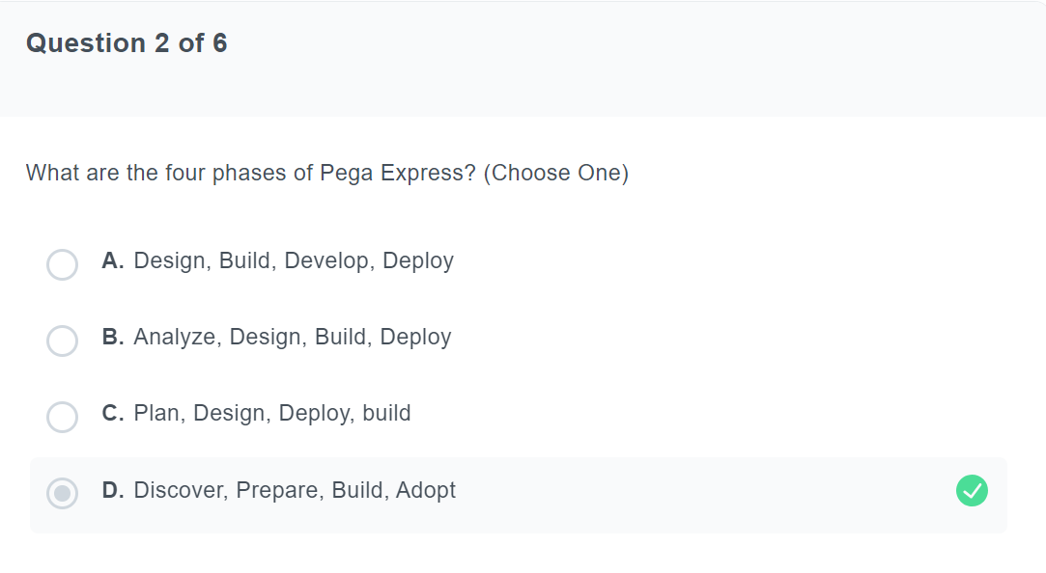

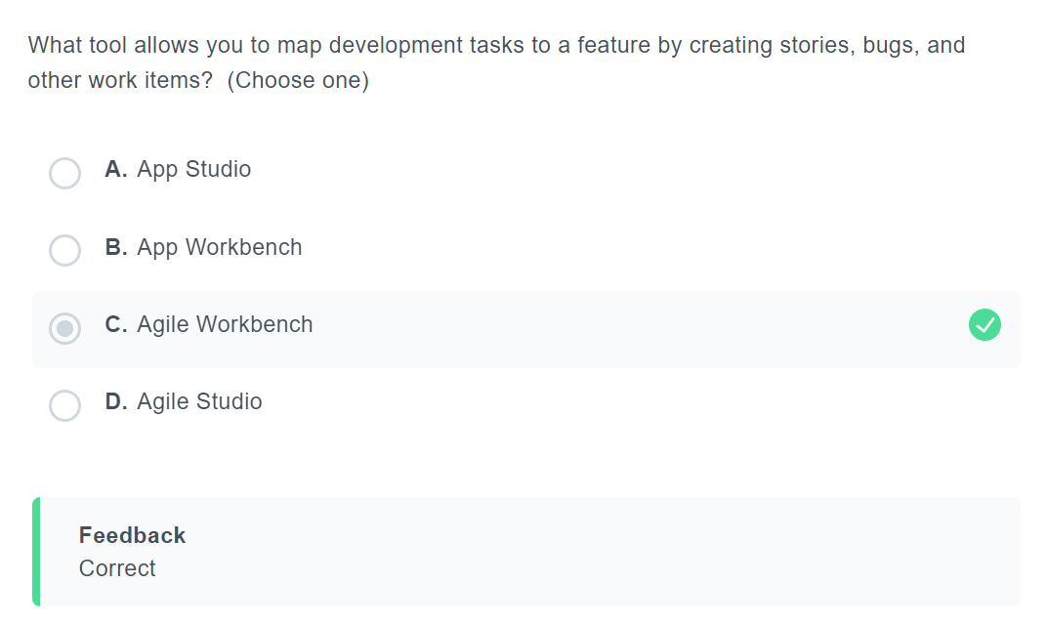

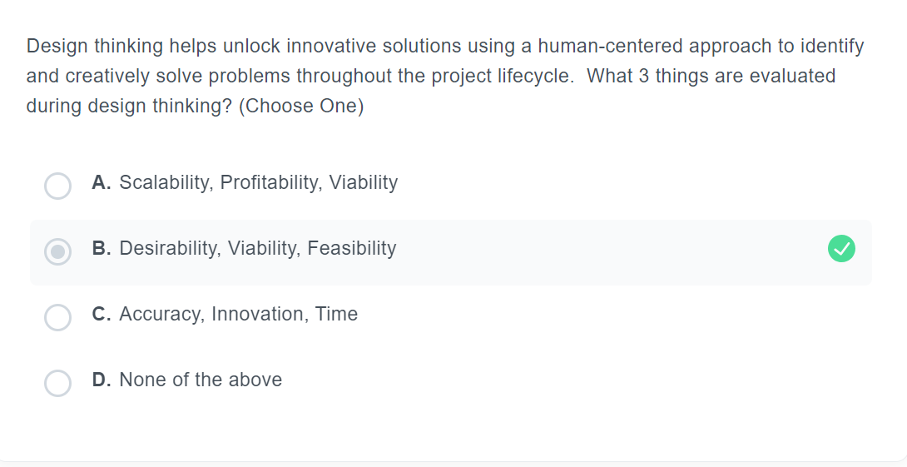

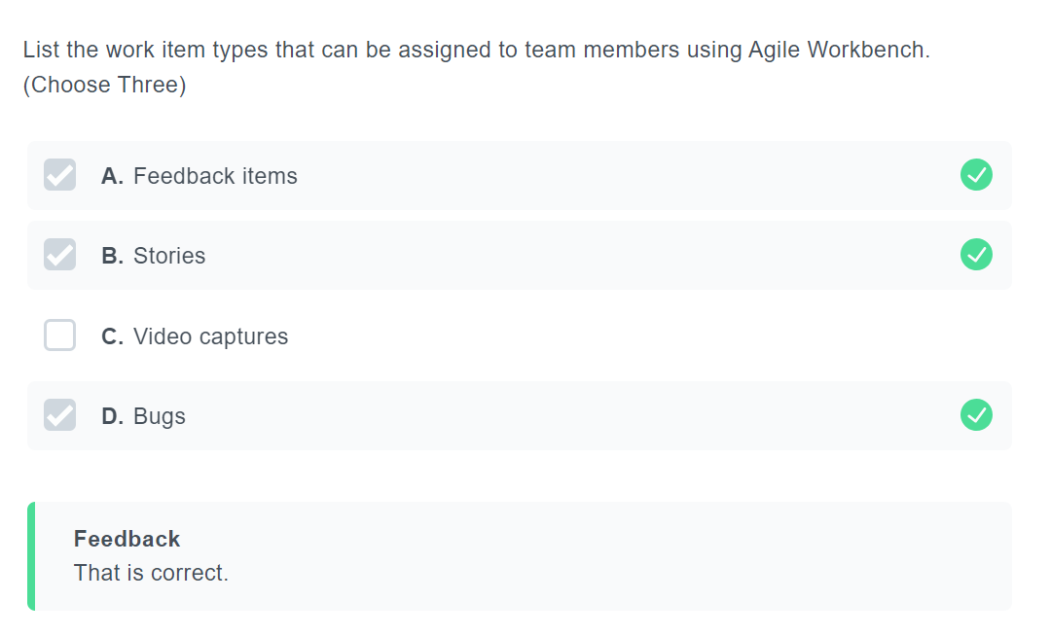

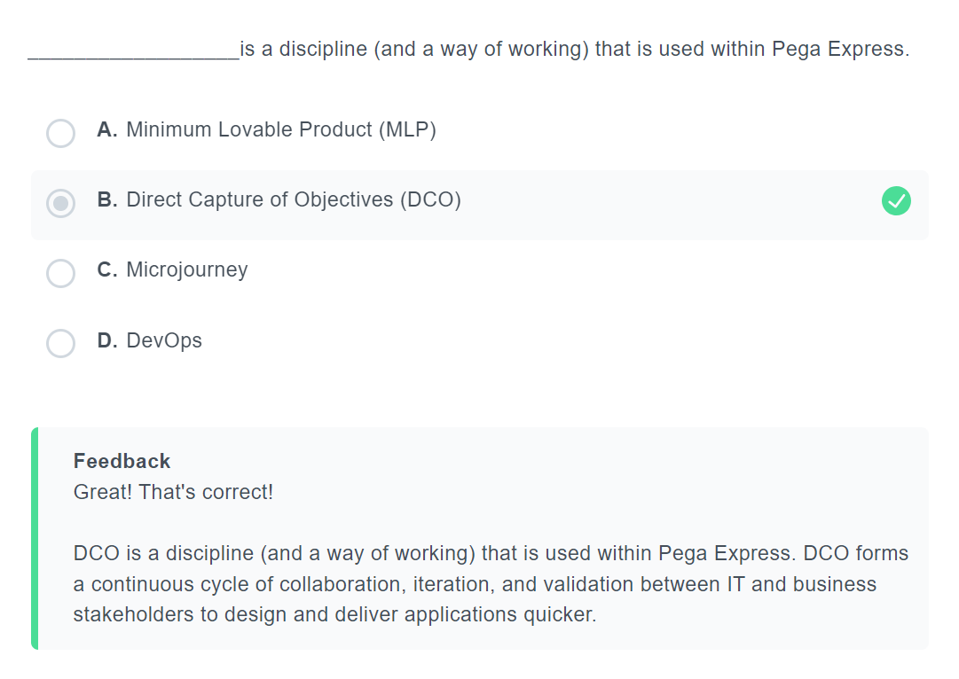

**Reporting 9%**

<https://www.classmarker.com/online-test/start/?quiz=akm622911b23df5d>

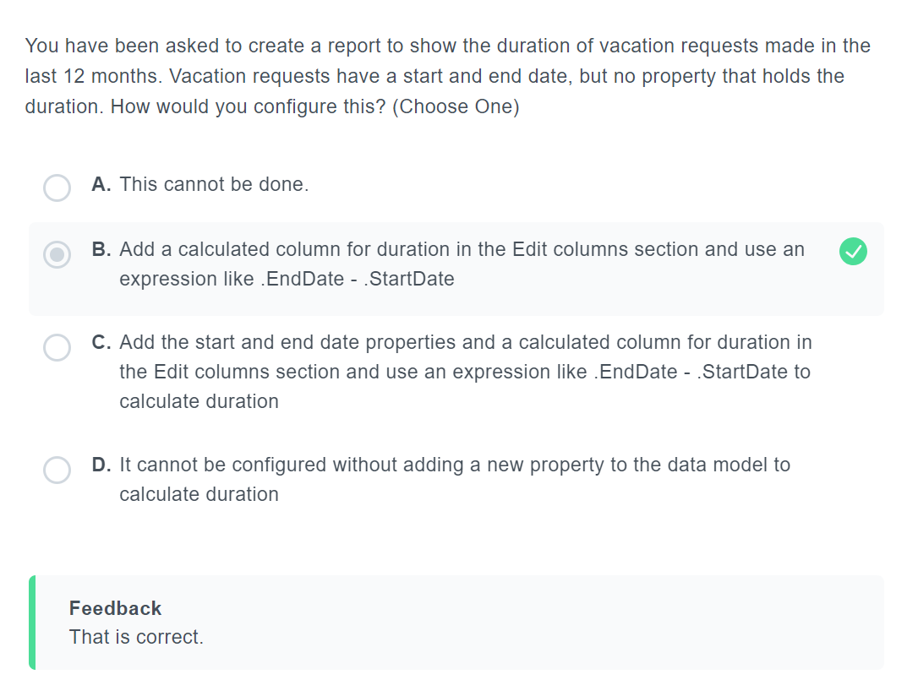

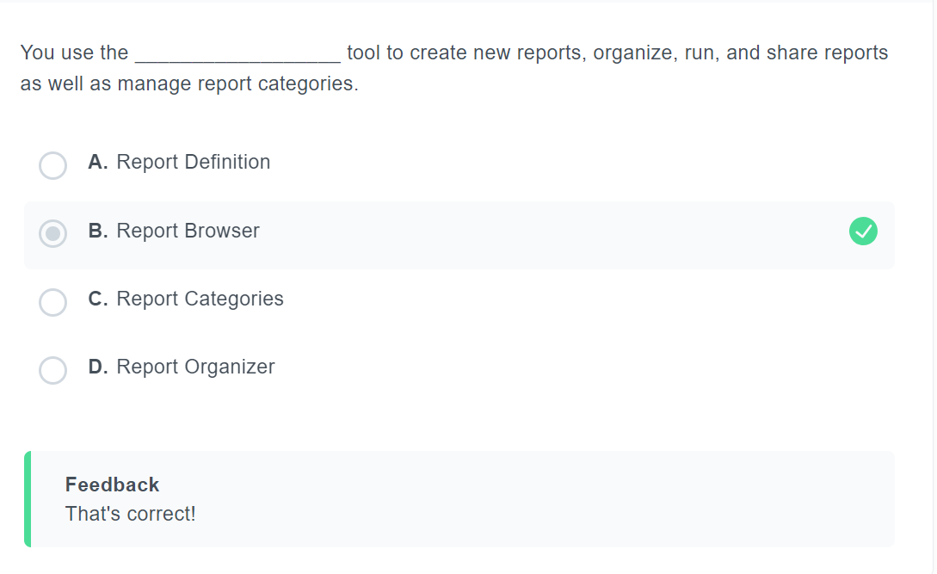

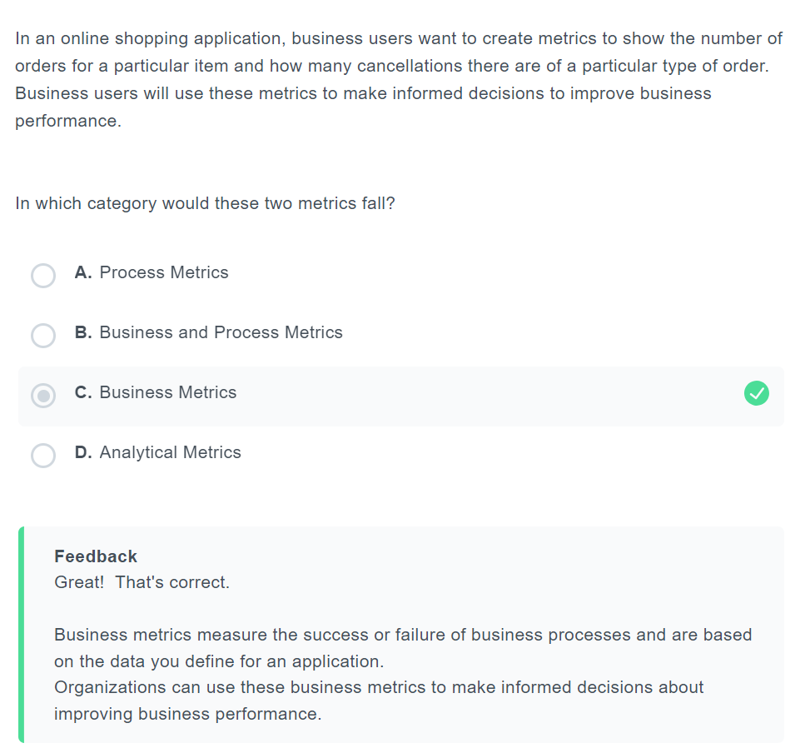

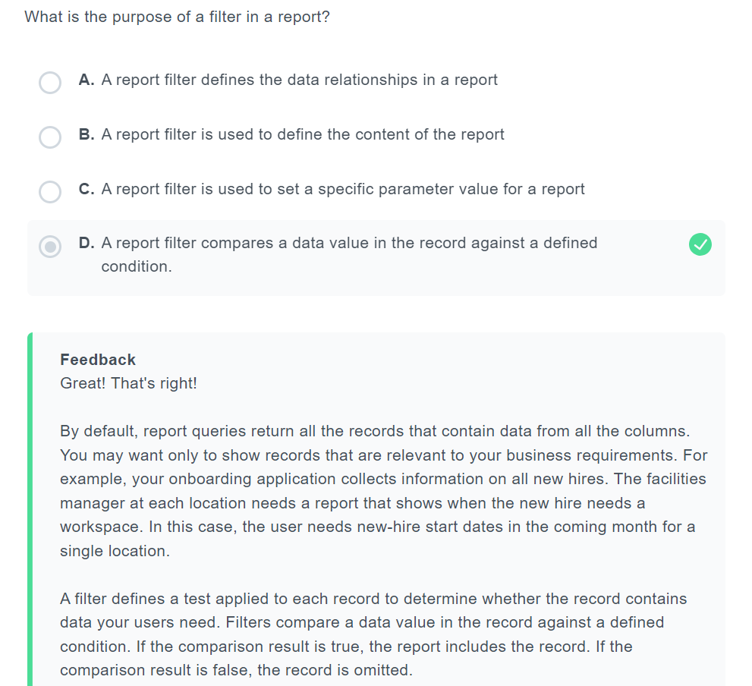

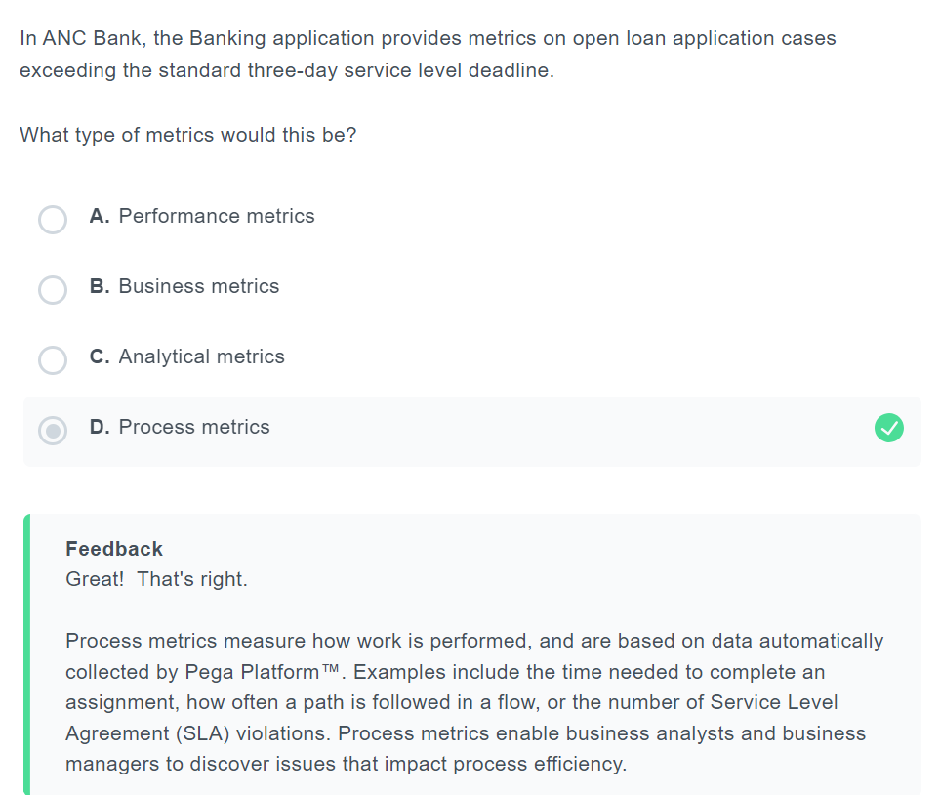

**User Experience 9%**

<https://www.classmarker.com/online-test/start/?quiz=cma62291f679e132>

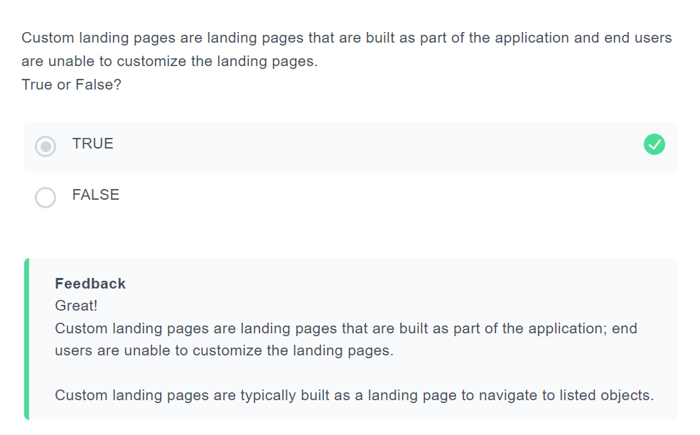

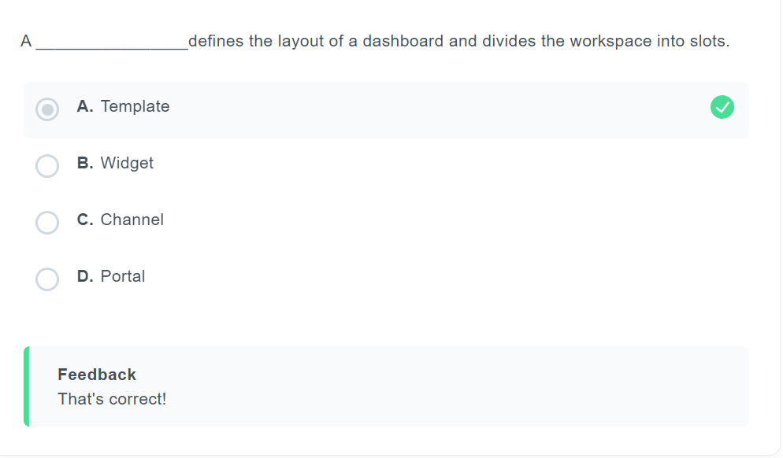

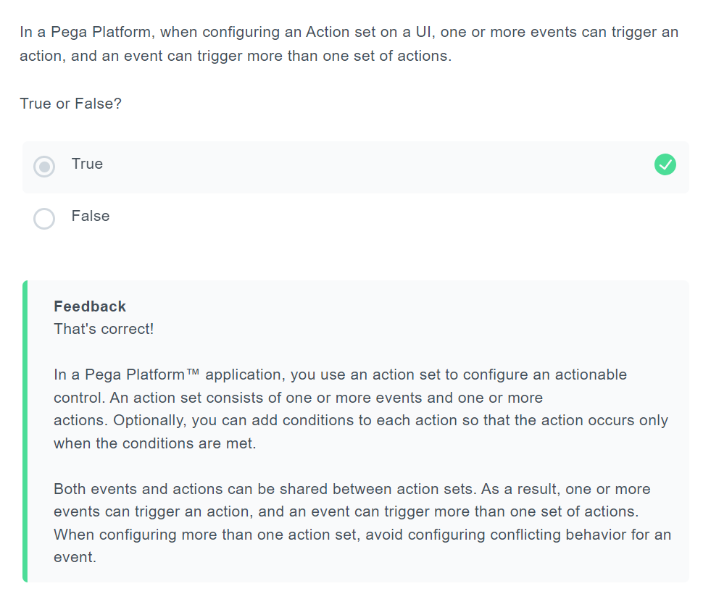

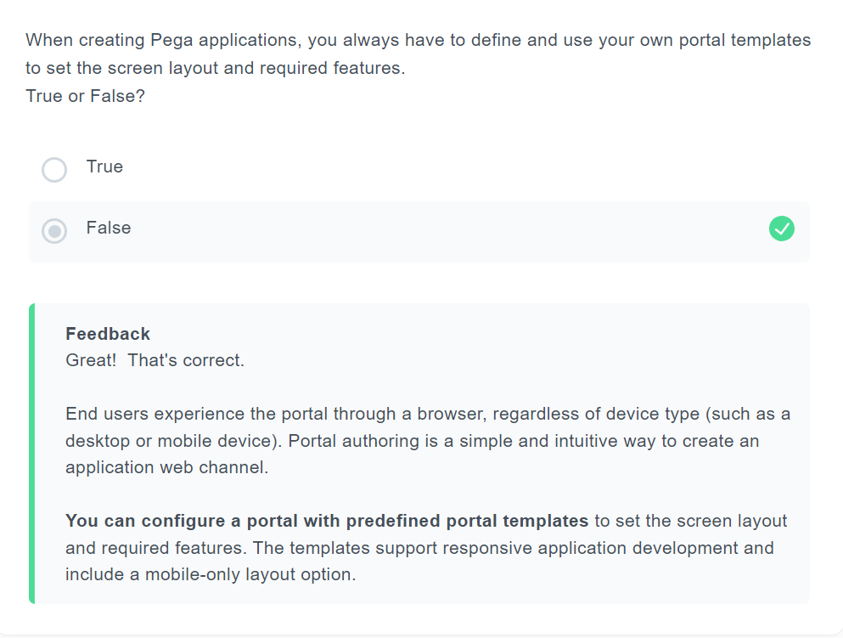

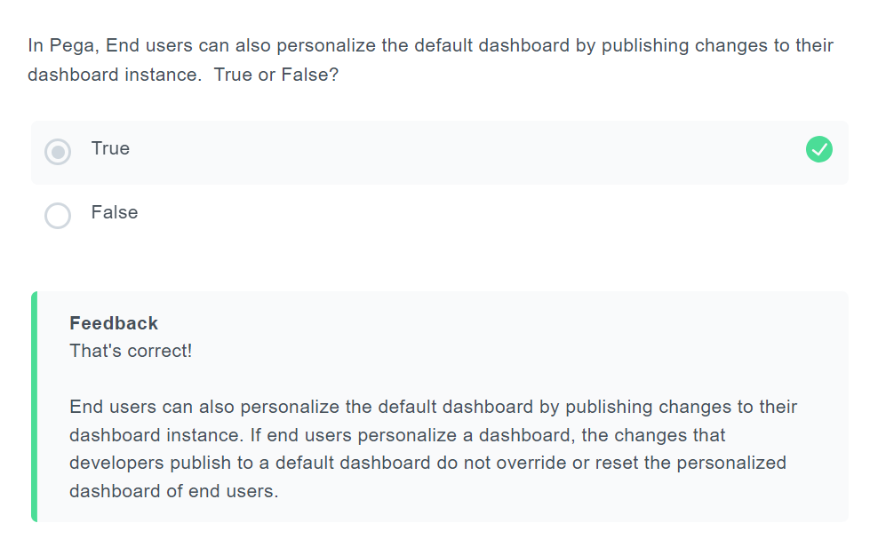

**Application Development 9%**

https://www.classmarker.com/online-test/start/?quiz=qyh62297397ae5f6

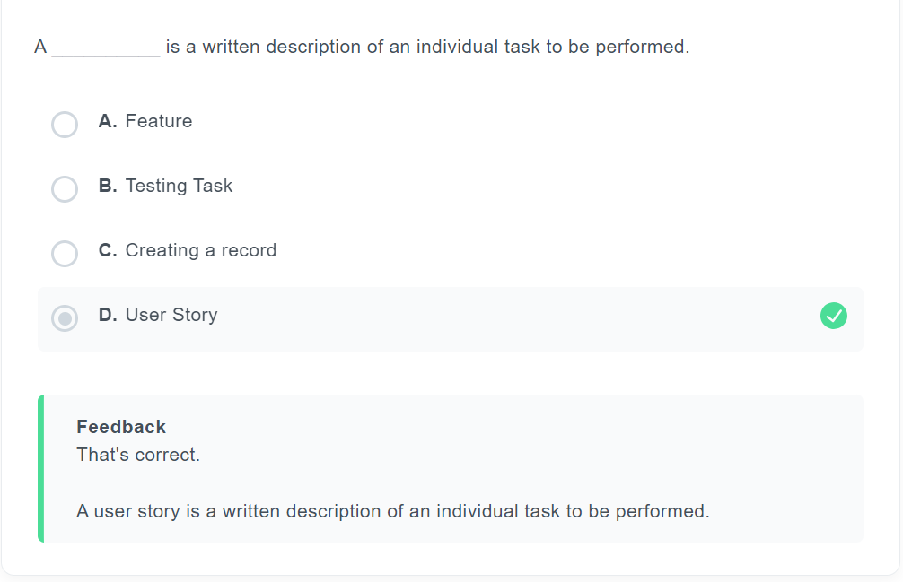

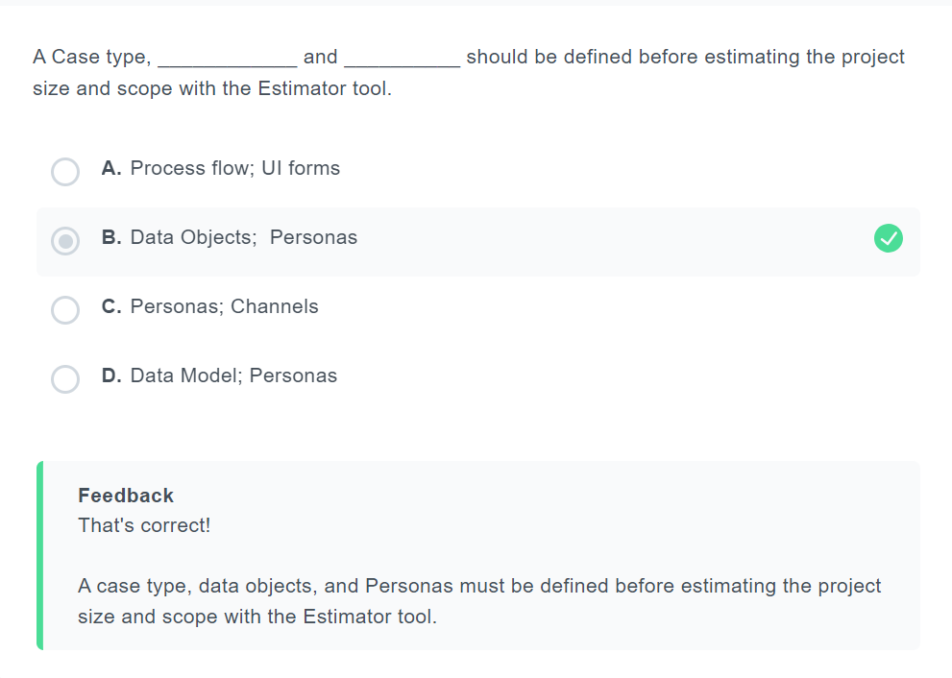

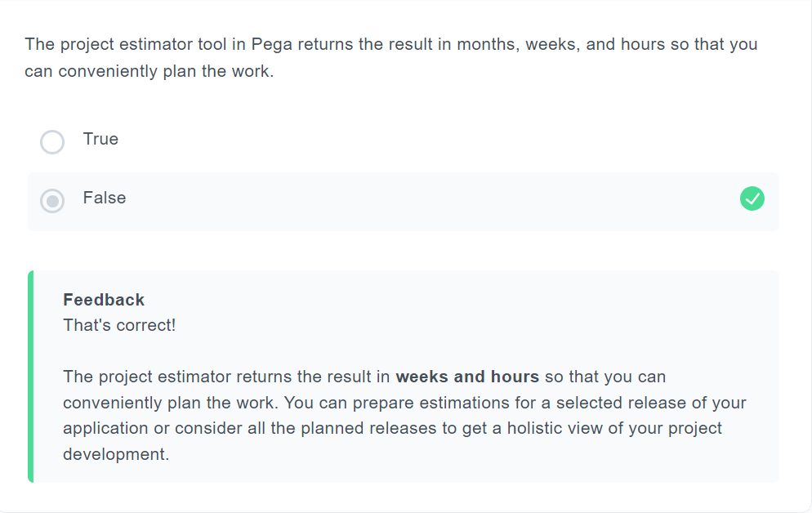

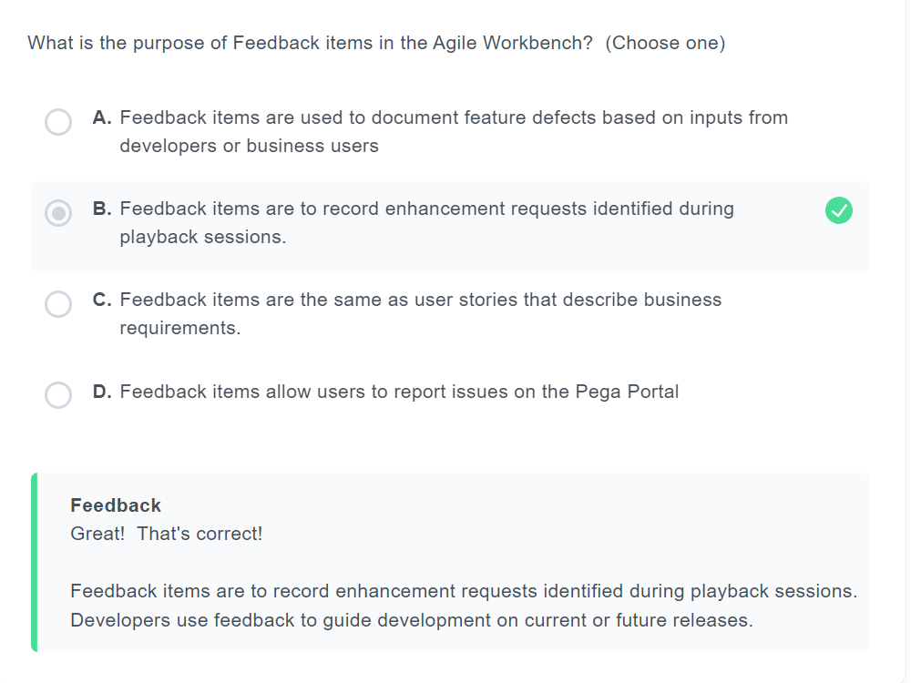

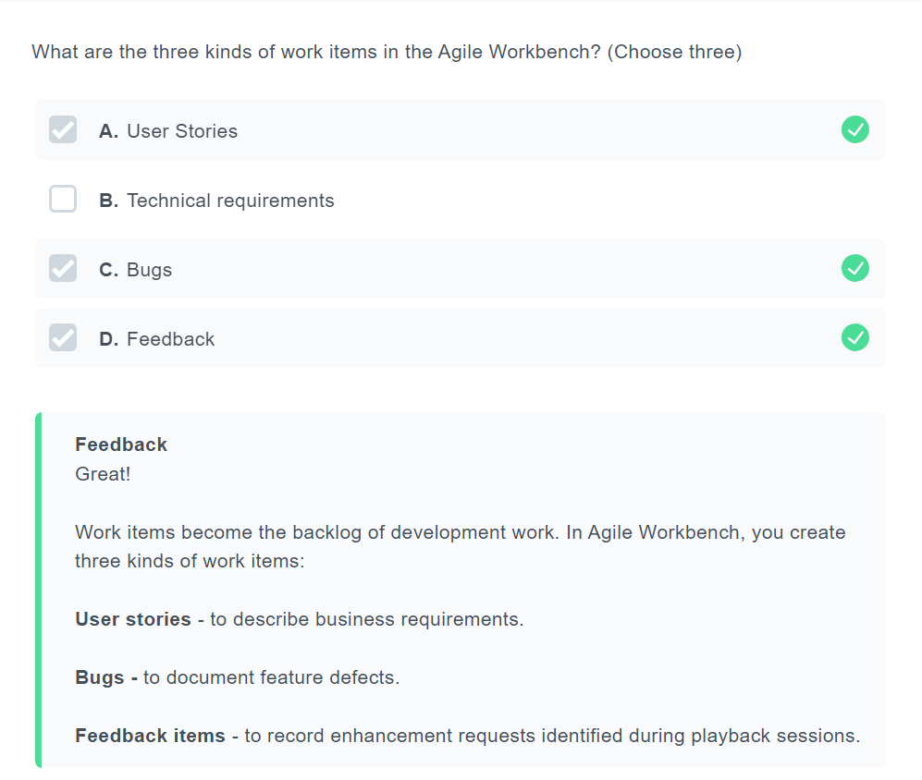

**Mobility 6% & Security 2%**

<https://www.classmarker.com/online-test/start/?quiz=jpv62297db3757e1>

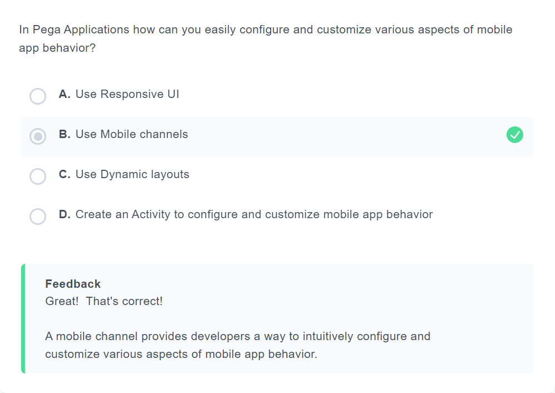

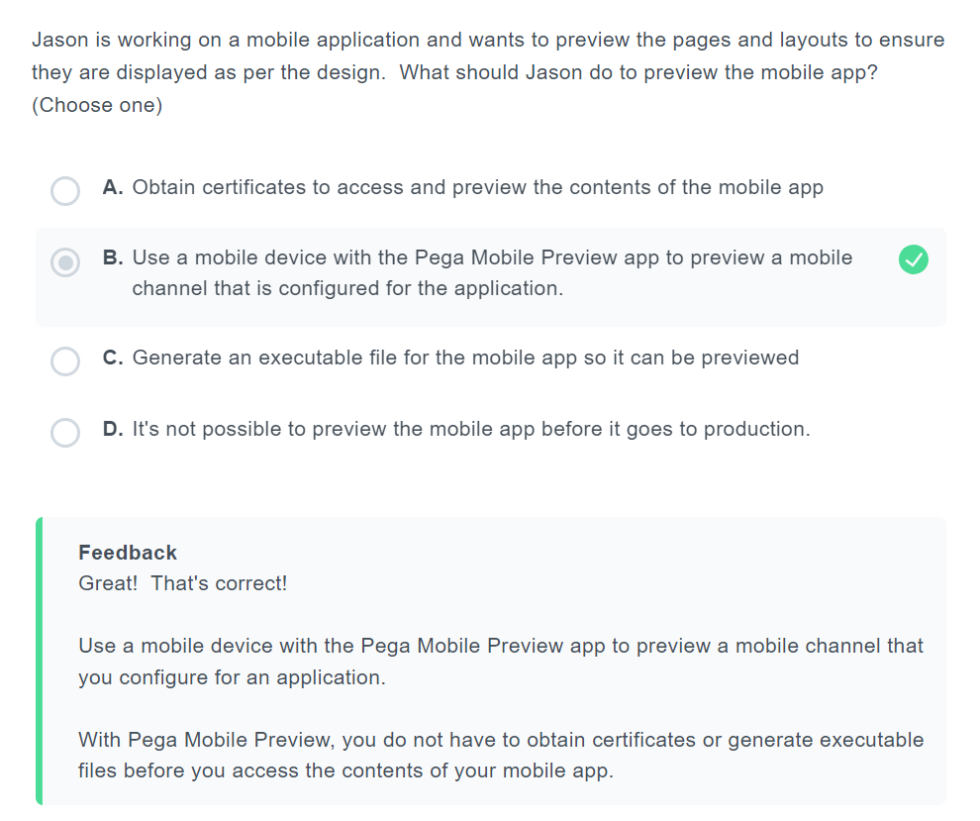

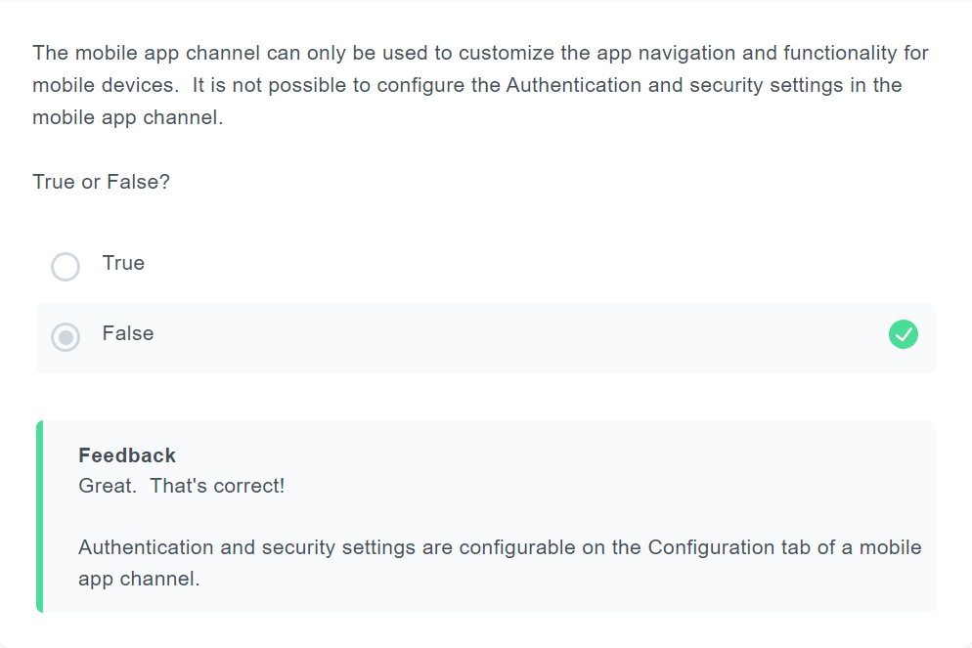

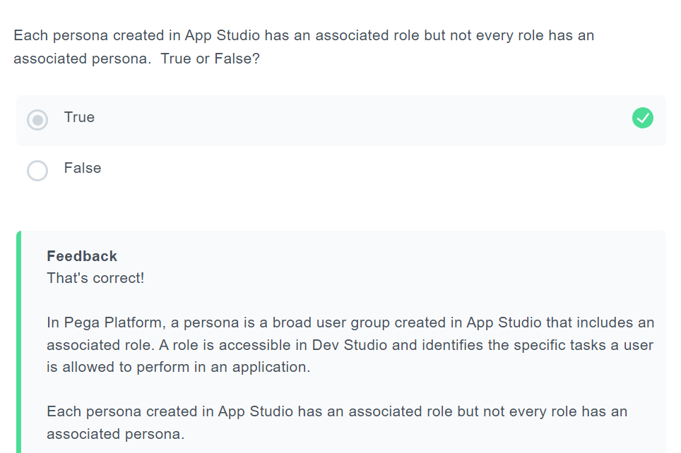

<https://www.classmarker.com/online-test/start/?quiz=gev6228cc8eba137>

<https://www.classmarker.com/online-test/start/?quiz=3a96228fdd7b4e89>

<https://www.classmarker.com/online-test/start/?quiz=n7n62290be9efdab>

<https://www.classmarker.com/online-test/start/?quiz=akm622911b23df5d>

<https://www.classmarker.com/online-test/start/?quiz=cma62291f679e132>

<https://www.classmarker.com/online-test/start/?quiz=qyh62297397ae5f6>

<https://www.classmarker.com/online-test/start/?quiz=jpv62297db3757e1>

**PCBA 8.7 Randomly generated 50 question practice exam:**

[**https://www.classmarker.com/online-test/start/?quiz=n7x62290967**](https://www.classmarker.com/online-test/start/?quiz=n7x6229096759c47)**59c47**

**Self Study Mission Test:**

[**https://academy.pega.com/mission/business-architect/v4/test/in/35761**](https://academy.pega.com/mission/business-architect/v4/test/in/35761)